1.A bakery sells loaves of bread for 185 rupees each. Day old bread is discounted by 60 percent. Write a python program that begins by reading the number of loaves of day old bread being purchased from the user. Then your program should display the regular price for the bread, the discount because it is a day old, and the total price. All of the values should be displayed using two decimal places, and the decimal points in all of the numbers should be aligned when reasonable values are entered by the user.

Sample Input: Enter the number of fresh loves purchased: 5

Enter the number of day old loaves purchased: 3

no= int(input ("enter the number"))

print ('Loaves Discount')

tmp=no*185

print("Regular Price",tmp)

tmp2=no*185*0.6

print("Total Discount",tmp2)

amount=tmp-tmp2

print("Total Amount to be paid",amount)

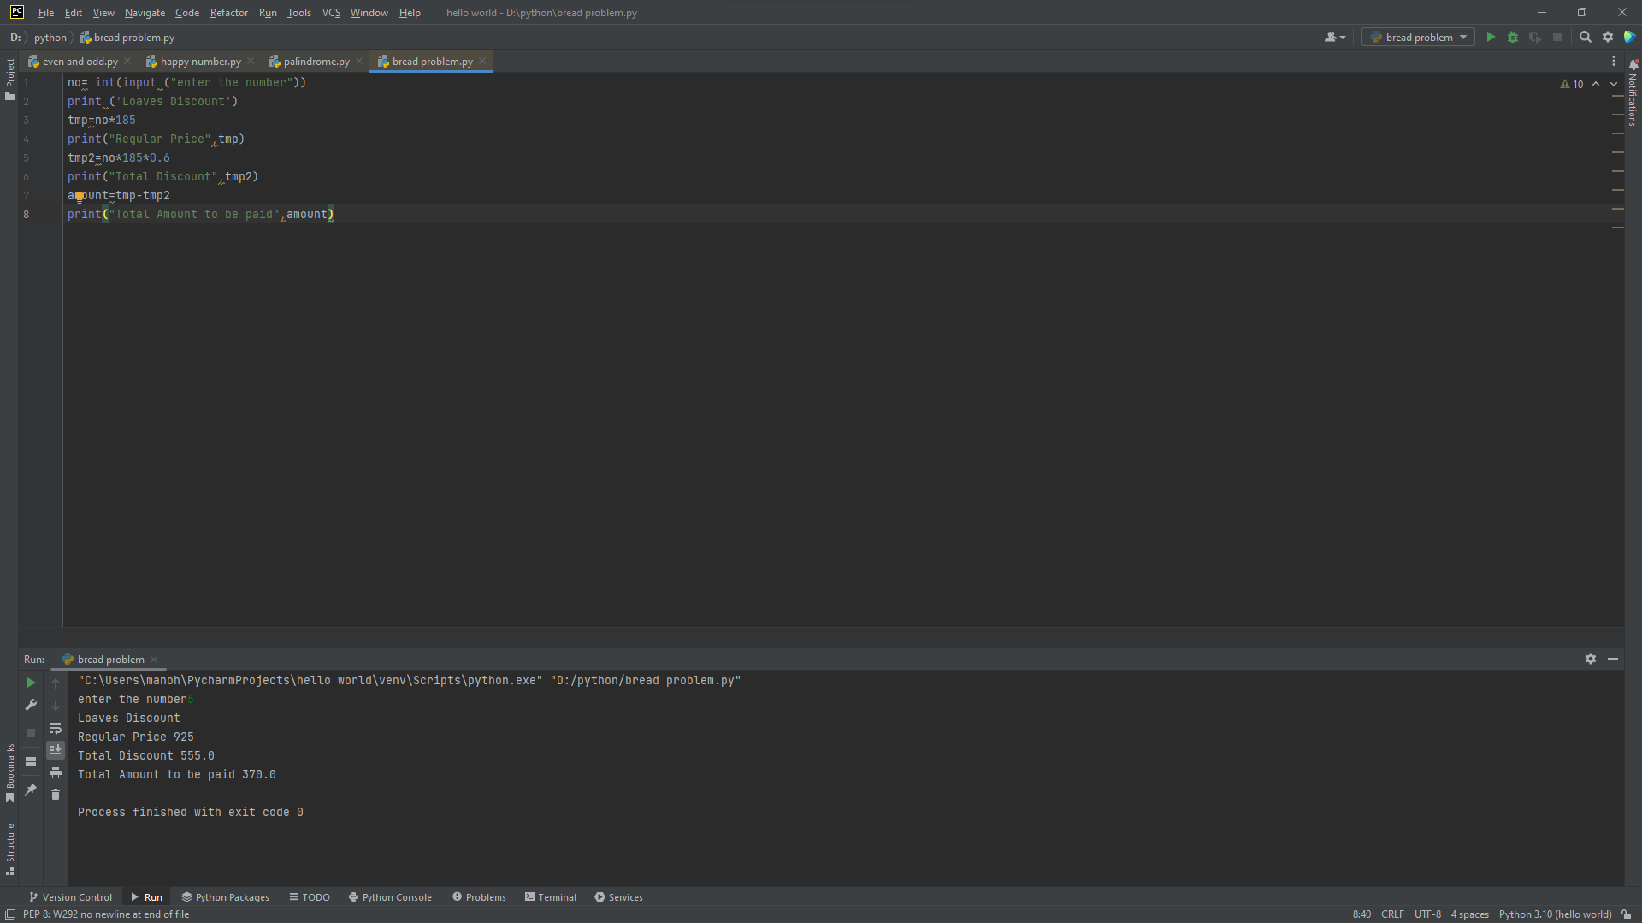

2. Given two strings “s” and “t”, determine if they are isomorphic. Two strings “s” and “t” are isomorphic if the characters in “s” can be replaced to get “t”. All occurrences of a character must be replaced with another character while preserving the order of characters. No two characters may map to the same character, but a character may map to itself.

def islsomorphic(str1,str2):

dict_str1={}

dict_str2={}

for i, value in enumerate(str1):

dict_str1[value]=dict_str1.get(value,[])+[i]

for j, value in enumerate(str2):

dict_str2[value]=dict_str2.get(value,[])+[j]

if sorted(dict_str1.values())==sorted(dict_str2.values()):

return True

else:

return False

print(islsomorphic("egg","add"))

print(islsomorphic("bar","foo"))

print(islsomorphic("paper","title"))

print(islsomorphic("fry","sky"))

print(islsomorphic("apples","apple"))

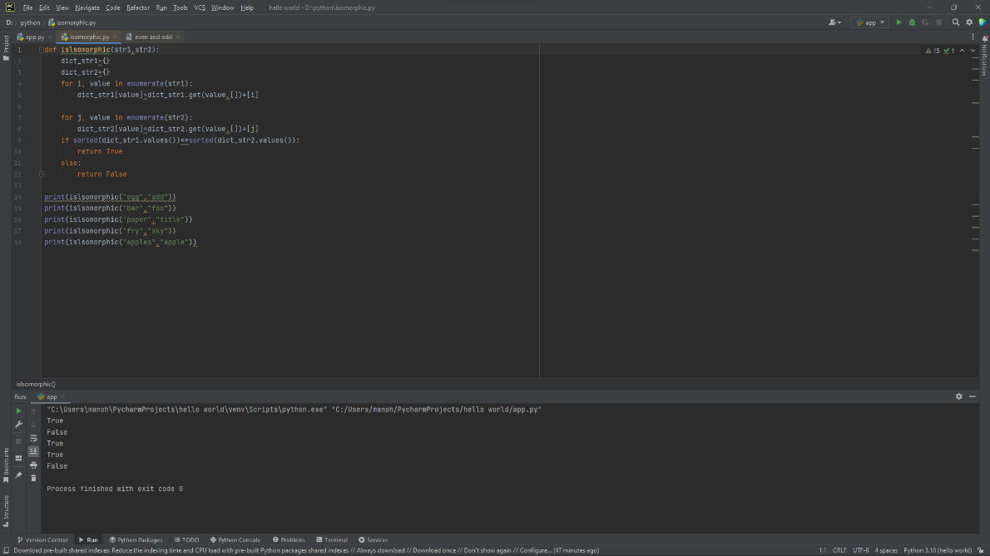

3. Given n non-negative integers a1,a2,a3,…an where each represents a point at coordinate (i, ai) . „ n „ vertical lines are drawn such that the two endpoints of line i is at (i, ai) and (i,0). Find two lines, which together with x-axis forms a container, such that the container contains the most water. The program should return an integer which corresponds to the maximum area of water that can be contained (maximum area instead of maximum volume sounds weird but this is the 2D plane we are working with for simplicity). Note: You may not slant the container.

def maxArea(A, Len):

area = 0

for i in range(Len):

for j in range(i + 1, Len):

area = max(area, min(A[j], A[i]) * (j - i))

return area

a = [1, 5, 4, 3]

b = [3, 1, 2, 4, 5]

len1 = len(a)

print(maxArea(a, len1))

len2 = len(b)

print(maxArea(b, len2))

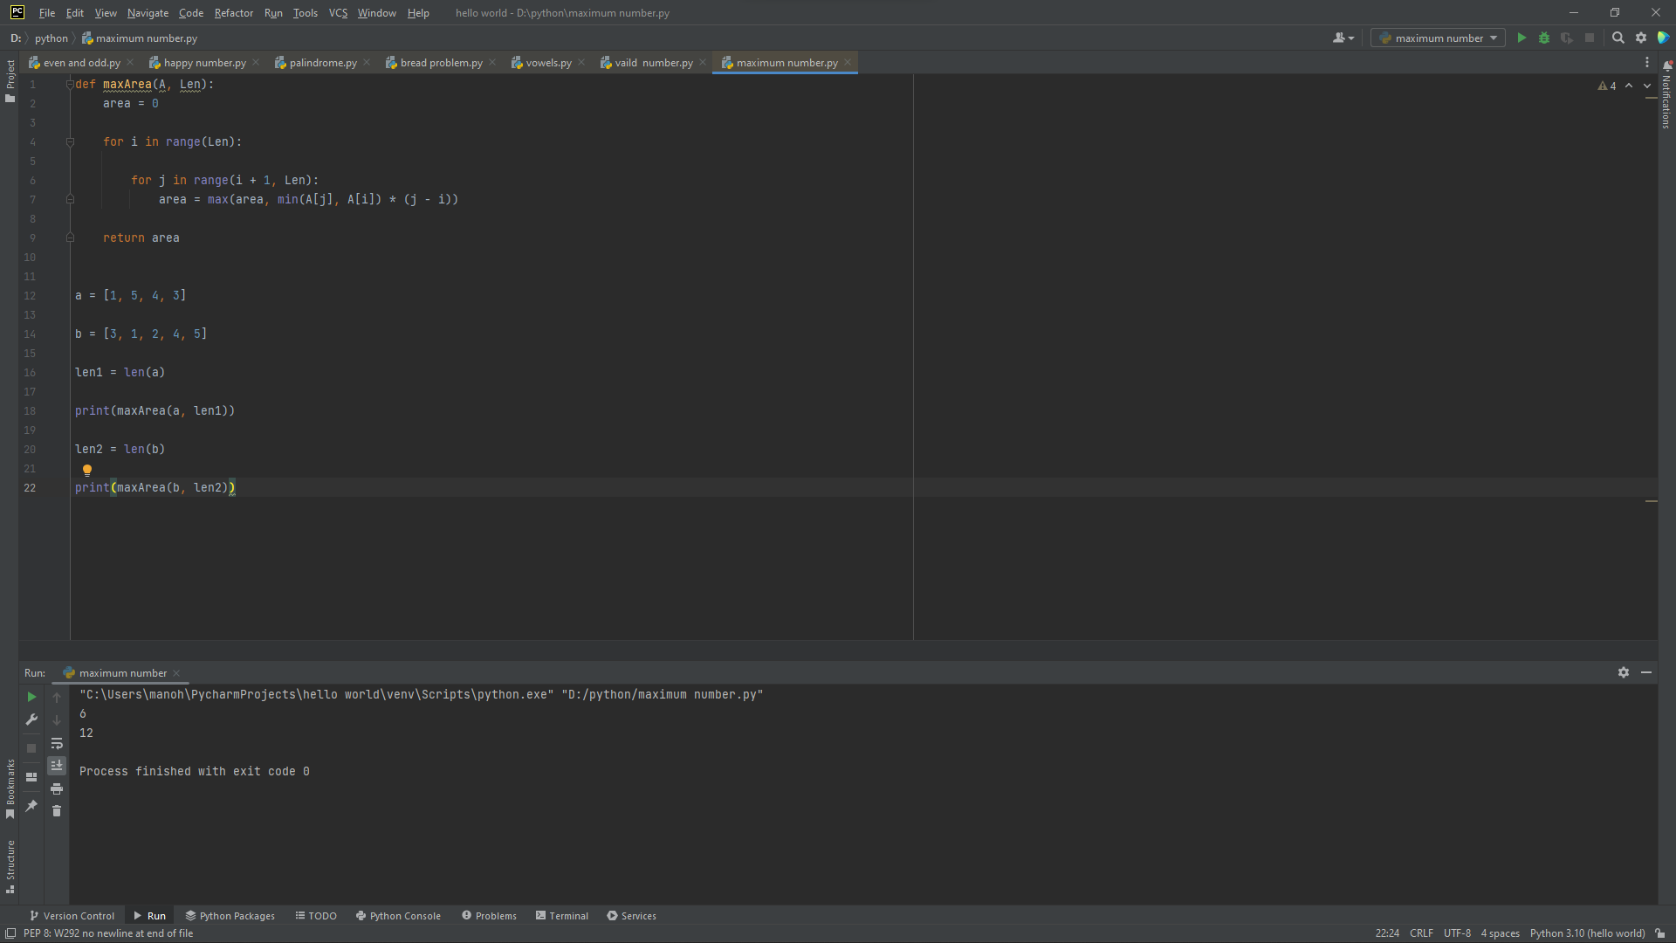

4.You are climbing a staircase. It takes n steps to reach the top. Each time you can either climb 1 or 2 steps. In how many distinct ways can you climb to the top?

def climbStairs(n):

steps = []

steps.append(1)

steps.append(2)

for i in range(2, n):

steps.append([i - 1] + [i - 2])

return steps[n - 1]

n=4

print(climbStairs(n))

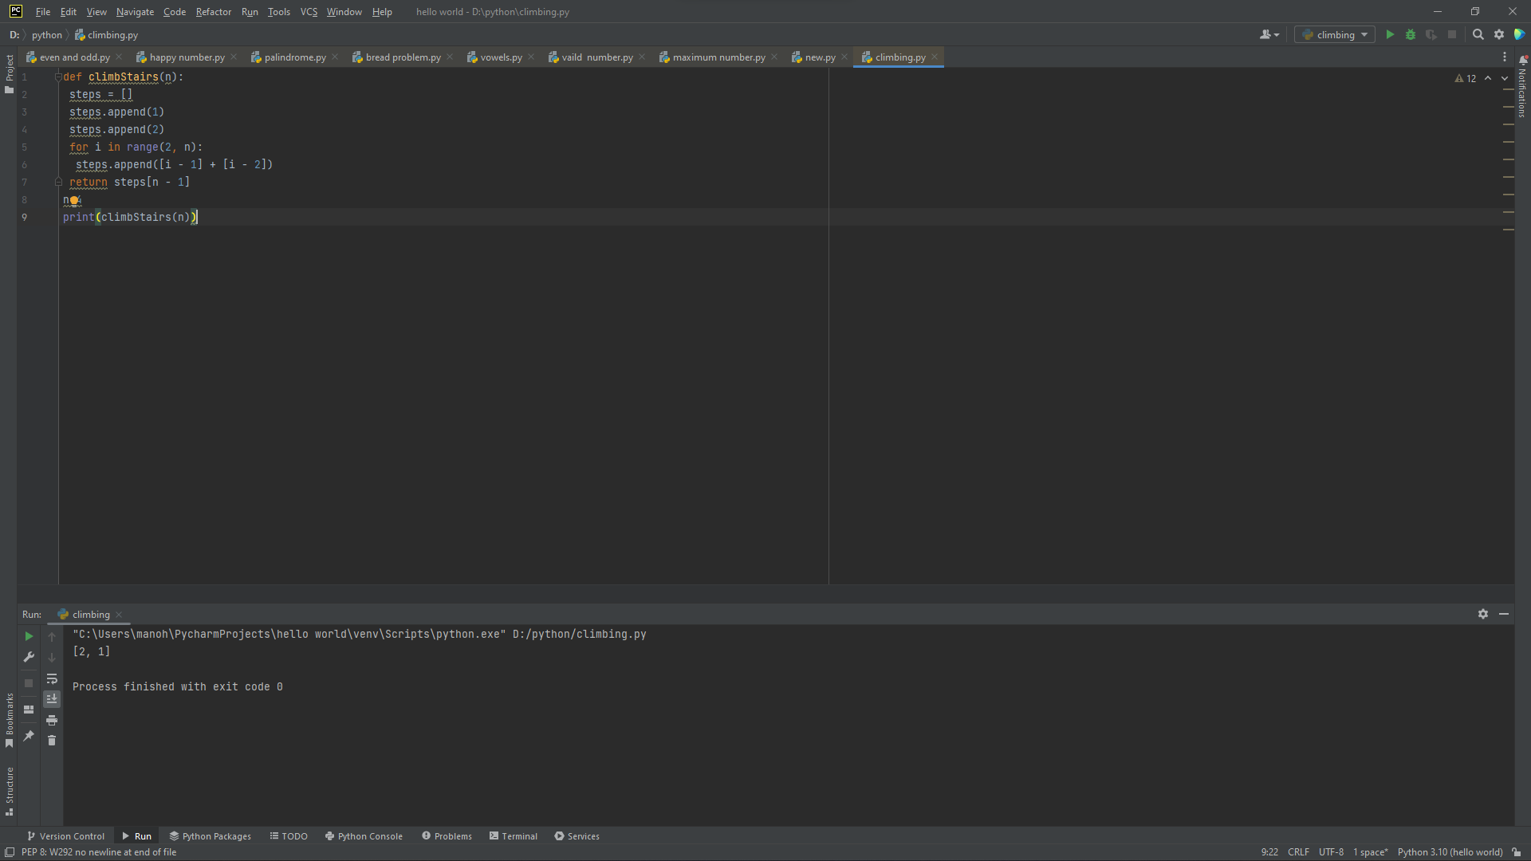

5. In daily share trading, a buyer buys shares in the morning and sells them on the same day. If the trader is allowed to make at most 2 transactions in a day, whereas the second transaction can only start after the first one is complete (Buy->sell->Buy->sell). Given stock prices throughout the day, find out the maximum profit that a share trader could have made.

import sys

def maxtwobuysell(arr, size):

first_buy = -sys.maxsize

first_sell = 0

second_buy = -sys.maxsize

second_sell = 0

for i in range(size):

first_buy = max(first_buy, -arr[i])

first_sell = max(first_sell, first_buy + arr[i])

second_buy = max(second_buy, first_sell - arr[i])

second_sell = max(second_sell, second_buy + arr[i])

return second_sell

if __name__ == '__main__':

arr = [10,22,5,75,65,80]

size = len(arr)

print(maxtwobuysell(arr, size))

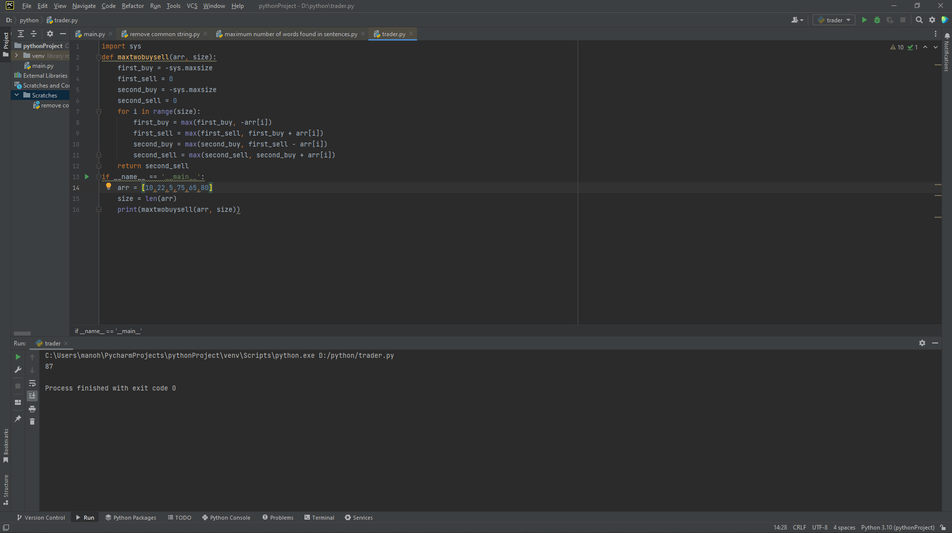

6. Given an integer n, return the number of strings of length n that consist only of vowels (a, e, i, o, u) and are lexicographically sorted. A string s is lexicographically sorted if for all valid i, s[i] is the same as or comes before s[i+1] in the alphabet.

def solve(n):

if n==1:

return 5

count = [1 for i in range(6)]

for i in range(3,n+1):

count[1] = count[1]+count[2]+count[3]+count[4]+count[5]

count[2] = count[2]+count[3]+count[4]+count[5]

count[3] = count[3]+count[4]+count[5]

count[4] = count[4]+count[5]

total = 0

for i in range(1,6):

total += i*count[i]

return total

n = 1

print(solve(n))

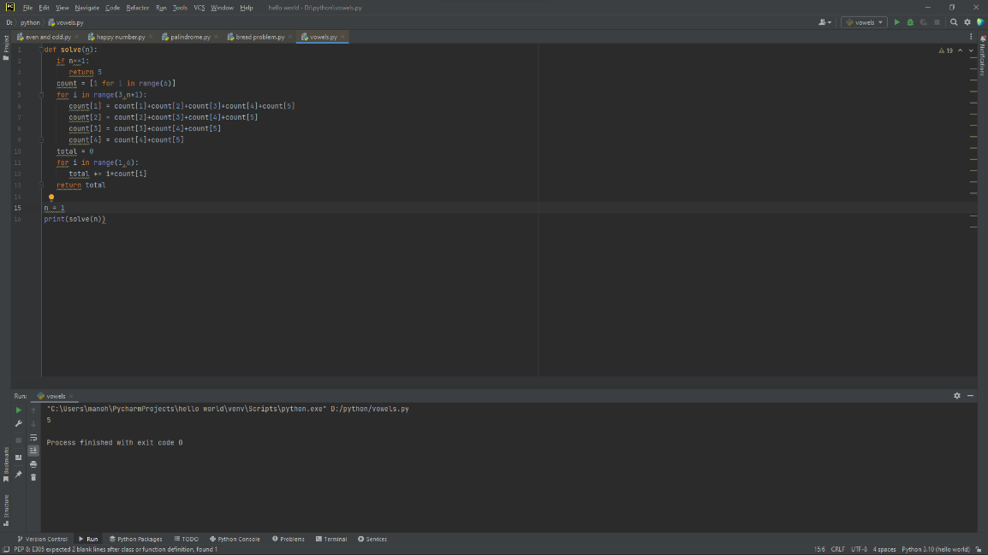

7.Given two binary strings a and b, return their sum as a binary string.

• a and b consist only of '0' or '1' characters.

• Each string does not contain leading zeros except for the zero itself.

def add_binary_nums(x, y):

max_len = max(len(x), len(y))

x = x.zfill(max_len)

y = y.zfill(max_len)

result = ''

carry = 0

for i in range(max_len - 1, -1, -1):

r = carry

r += 1 if x[i] == '1' else 0

r += 1 if y[i] == '1' else 0

result = ('1' if r % 2 == 1 else '0') + result

carry = 0 if r < 2 else 1

if carry != 0: result = '1' + result

return result.zfill(max_len)

print(add_binary_nums('1010', '1011')) 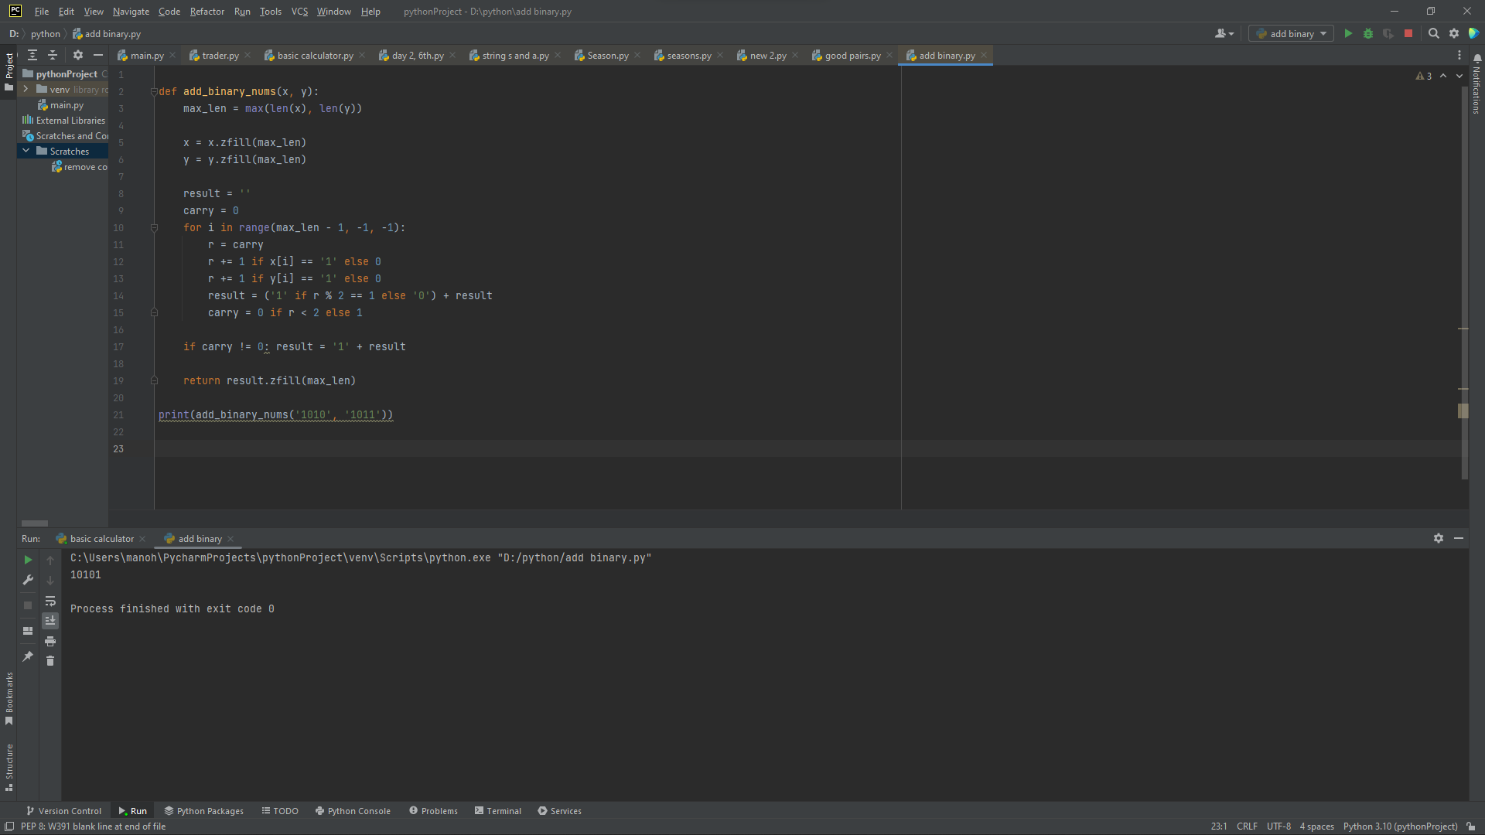

Given a string s which represents an expression, evaluate this expression and return its value. The integer division should truncate toward zero. You may assume that the given expression is always valid. All intermediate results will be in the range of [-231, 231 - 1].

• s consists of integers and operators ('+', '-', '*', '/') separated by some number of spaces.

• s represents a valid expression.

• All the integers in the expression are non-negative integers in the range [0, 231 - 1].

• The answer is guaranteed to fit in a 32-bit integer. Note: You are not allowed to use any built-in function which evaluates strings as mathematical expressions, such as eval().

def add (x,y):

return x+y

def sub (x, y):

return x-y

def mult (x, y):

return x*y

def div (x, y):

return x/y

print ("select operation")

print ("1.add")

print ("2.sub")

print ("3.mult")

print ("4.div")

choice=input("enter choice (1/2/3/4):")

if choice in ("1","2","3","4"):

a=int(input ("enter the number 1:"))

b=int(input ("enter the number 2:"))

if choice=="1":

print (a, "+",b, "=", add (a, b))

elif choice=="2":

print (a, "-",b, "=", sub (a,b))

elif choice=="3":

print (a, "*",b,"=",mult (a, b))

elif choice=="4":

print (a,"/",b,"=", div(a,b))

else:

print ("invalid input")

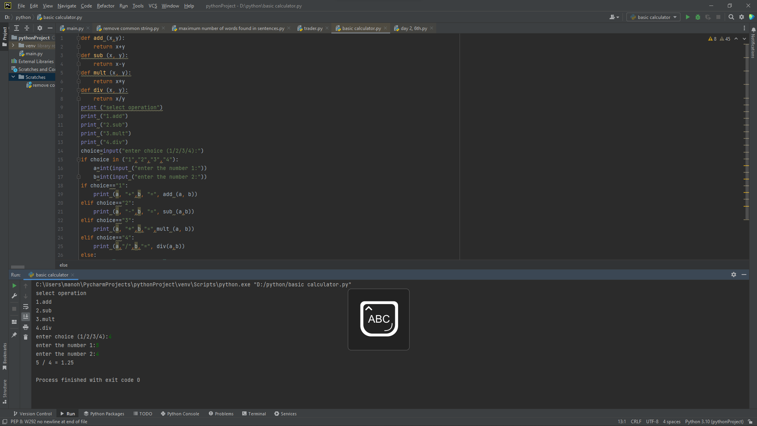

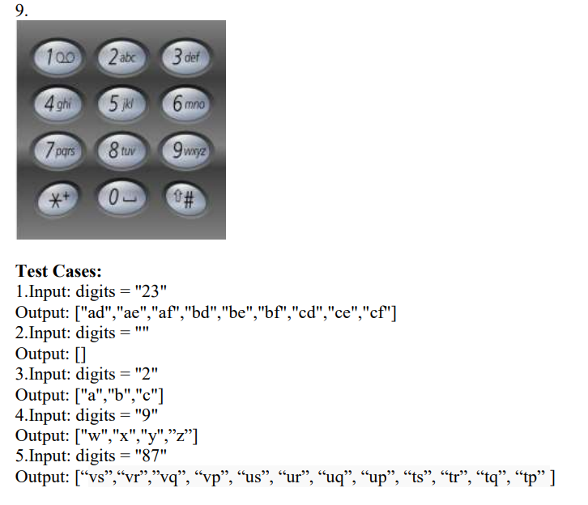

class solution (object):

def lettercombinations(self,digits):

if len(digits)==0:

return []

characters = {2:"abc",3:"def",4:"ghi",5:"jkl",6:"mno",7:"pqrs",8:"tuv",9:"wxyz"}

result=[]

self.solve(digits,characters,result)

return result

def solve(self,digits,characters,result,current_strings="",current_level =0):

if current_level == len(digits):

result.append(current_strings)

return

for i in characters[int(digits[current_level])]:

self.solve(digits,characters,result,current_strings+i,current_level+1)

ob1 = solution()

m= (input("enter the numbers"))

print(ob1.lettercombinations(m))

10. Given an integer n, return the least number of perfect square numbers that sum to n.

A perfect square is an integer that is the square of an integer; in other words, it is the product

of some integer with itself. For example, 1, 4, 9, and 16 are perfect squares while 3 and 11 are

not.

Test cases:

1.Input: n = 12 output: 3

2. Input: n = 13, Output: 2

3.Input : n= 1, Output: 1

4.Input: n=4, Output: 2

5.Input: n=3, Output: 1

def getMinSquares(n):

if n <= 3:

return n;

res = n

for x in range(1, n + 1):

temp = x * x;

if temp > n:

break

else:

res = min(res, 1 + getMinSquares(n- temp))

return res;

s=int(input("enter the number"))

print(getMinSquares(s)) 